You are given a network of n nodes, labeled from 1 to n. You are also given times, a list of travel times as directed edges times[i] = (ui, vi, wi), where ui is the source node, vi is the target node, and wi is the time it takes for a signal to travel from source to target.

We will send a signal from a given node k. Return *the* ***minimum*** *time it takes for all the* n *nodes to receive the signal*. If it is impossible for all the n nodes to receive the signal, return -1.

**Example 1:**

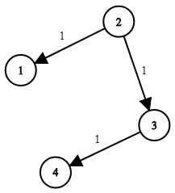

Input: times = [[2,1,1],[2,3,1],[3,4,1]], n = 4, k = 2  
Output: 2

**Example 2:**

Input: times = [[1,2,1]], n = 2, k = 1  
Output: 1

**Example 3:**

Input: times = [[1,2,1]], n = 2, k = 2  
Output: -1

**Constraints:**

* 1 <= k <= n <= 100
* 1 <= times.length <= 6000
* times[i].length == 3
* 1 <= ui, vi <= n
* ui != vi
* 0 <= wi <= 100
* All the pairs (ui, vi) are **unique**. (i.e., no multiple edges.)